Profile:
I am looking for an opportunity to further my knowledge in building quality experiences that exceed expectations in interactive media.

Technical Skills:
Image Programs: 3D Studio Max, Maya, Blender, Photoshop, Gimp
Languages: Python, Java, C++, C, Perl, Visual Basic, Shell, PL/SQL, SQL, AS3
Game Engines: Unity, Ogre, Unreal Tournament
Web Technology: EDI, XML, HTML, PHP, SOAP, WSDL
Configuration Management: Kintana, ant, subversion, CVS
Databases: Oracle, MySQL, Access

Awards and Conferences:
2010 Adobe Design Achievement Awards: Semi-finalist for Combiform: Shooter
2010 Meaningful Play Conference: Most Innovative for Combiform: Bisho Bisho Bailout
2010 Meaningful Play Conference: Runner-up Best in Show for Combiform: Bisho Bisho Bailout
2011 Game Show NYC: Will Present Elephant in the Relationship
2011 Annenberg Crunch Design Challenge: 1st place for New Tools and Applications: Combiform
2011 Exhibited Combiform at TEDxUSC

Experience:
2-2006 to Present Independent Game Developer/Inventor Los Angeles, CA
- Developed games and applications using programming, design, and graphics skills.
- Developed custom interactive hardware applications with integrated circuits (IC), Arduino, and other electronics components.
- Created twenty-three digital/interactive experiences (see attached Portfolio with excerpts below).
- Co-author of a utility patent which is currently patent pending.

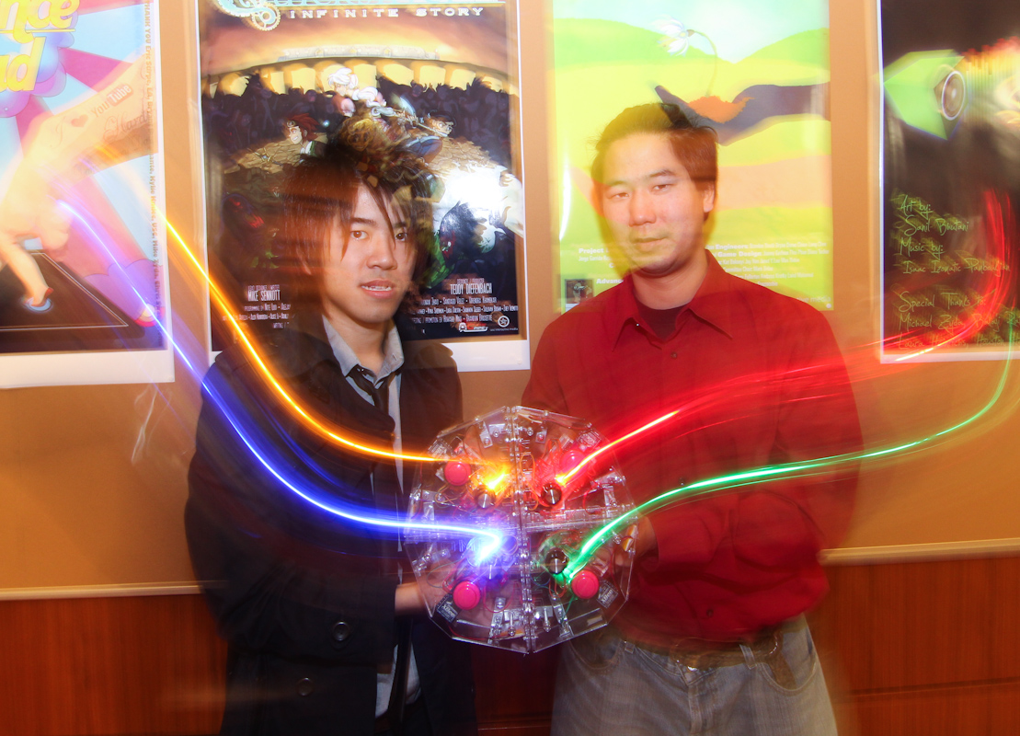
Combiform Gaming Platform (2-2010 to Present)
Position: Co-creator and software architect
Software used: AS3Glue, Flash
Hardware used: Arduino, Xbee
Description: Game controllers that are designed to break down the invisible wall between players interacting together. The players interact by physically combining the controllers and jointly controlling a new avatar.

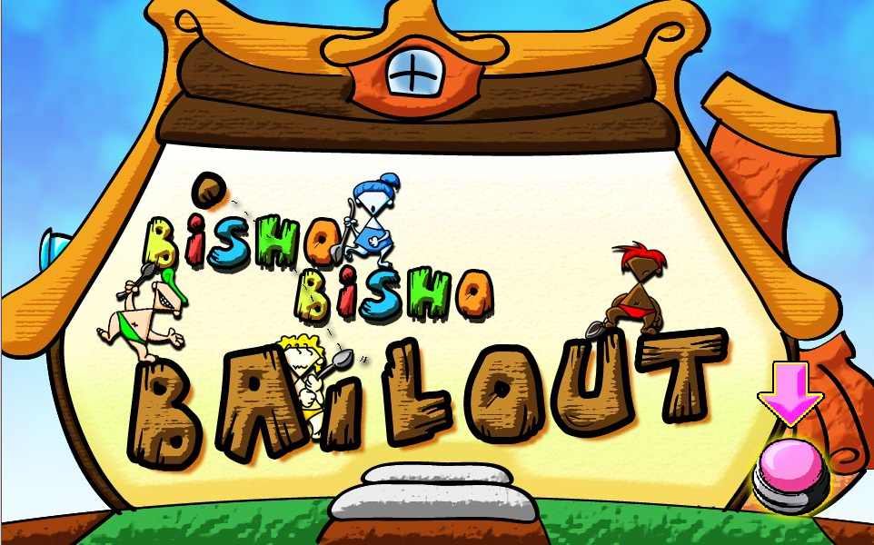
CombiForm: Bisho Bisho Bailout (8-2010 to Present)
Awards: Meaningful Play 2010: Most Innovative Award
Meaningful Play 2010: Runner-up Best in Show
Position: Designer and developer
Software used: Flash
Link: http://www.youtube.com/watch?v=uDIdHnro0HQ
Description: Babies must fight the rising tide by bailing water with spoons. Players must cooperate to save themselves and the house by using the unique mechanics of the Combiform platform.

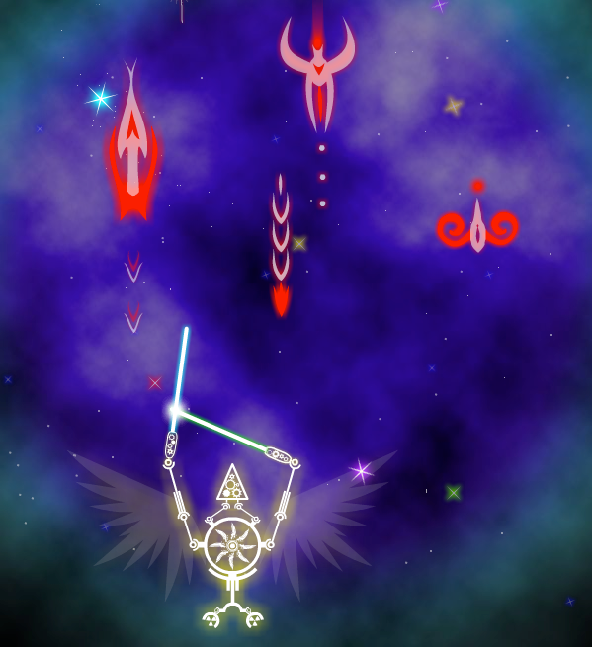
CombiForm: Shooter (2-2010 to Present)
Awards: Adobe Design Achievement Awards, 2010 Semi-finalist
Position: Co-creator and developer
Developed: February to April 2010 (Version 1)
Software used: Flash
Link: http://www.youtube.com/watch?v=uDIdHnro0HQ
Description: A game that allows players to experience their fantasy as a Mighty Morphin Power Rangers like heroes. Players control their own battle vessel. Players combine controllers to make a mega robot to defeat evil!

5-2010 to 8-2010 Wemo Media Los Angeles, CA
Game Design Intern
- Designed additional gameplay features for core products.
- Designed user interface for core product.
- Worked closely with outsourced partner to make sure all deliverables where completed on-time.

11-2009 to 5-2010 USC Game Innovation Lab Los Angeles, CA
Game Designer
- Game tester for a game aimed at teaching and motivating high school students to go to college.
- Collaborated in the game design for the Facebook version of the game.

8-2004 to 2-2006 Great-West Life & Annuity Insurance Company (GWL) Denver, CO
TIBCO Programmer/Architect
- Architected and contributed to the implementation of a TIBCO service oriented architecture (SOA) for GWL’s website mygreatwest.com. The website served over 100k members.
- Developed general TIBCO infrastructure requirements, with consideration for disaster recovery, HIPAA compliance, performance cost, growth, and maintenance.
- Defined and implemented coding standards at GWL. Presented these standards at the Rocky Mountain TIBCO User Group meeting.

8-2002 to 8-2004 Expanets / Avaya Denver, CO
webMethods Production Manager
- Provided 24/7 production support as the primary administrator for webMethods Enterprise, Integration Server, and Workflow. Maintained three environments for a 98% uptime.
- Designed and developed pl/sql, Korn shell, perl scripts, and java code to monitor and optimize system up time and perform data fixes.
- Supervised a junior administrator.
Military: 1994-2000 United State Marine Corps Platoon Sergeant
Education: B.S. in Computer Science and Philosophy, University of Wisconsin-Milwaukee
MFA Candidate in Interactive Media, University of Southern California (anticipated 2012)

References Available Upon Request

